Happiest Minds’ Proposal to Aptech Ltd

13th April 2024



**Copyright Information**

This document is the exclusive property of Happiest Minds Technologies Ltd. (“Happiest Minds”). The recipient agrees that they may not copy, transmit, use, or disclose the confidential and proprietary information in this document by any means without the expressed and written consent of Happiest Minds. By accepting a copy, the recipient agrees to adhere to these conditions to the confidentiality of Happiest Minds practices and procedures.

**Confidentiality Clause**

This document is being submitted to Aptech by Happiest Minds Technologies Ltd. on the understanding that the contents of this document will not be divulged to any third party without the express written consent of the parties. It is also understood that the parties will not divulge any confidential information about Aptech that it may have access to during this interaction.

**Disclaimer**

This document has been prepared based on the information provided by Aptech. Wherever proposed, the solutions and/or services mentioned are based on the requirements defined and understood by us at the time of preparing this document. While every effort has been made to make this document as accurate as possible, there might be changes to the document based on the subsequent discussions.

**Table of Contents**

1. Executive Summary 4

2. About Happiest Minds 5

Mission, Vison & Values 5

Focus on Disruptive Technologies 6

Awards, Certifications & Accolades received 6

Our Business 7

Our Solutions & IPs 11

Our Edtech domain expertise 12

3. Requirement Summary 15

Overview 15

REQUIREMENT DETAILS 15

In Scope 19

Out of Scope 19

Assumptions 19

Dependencies 19

4. SOLUTION DESIGN & APPROACH 21

Guiding Principles 21

Design Principles 21

Reference Architecture 22

Thick Client Assessment Player 25

Security Considerations 27

Performance Considerations 27

TAO – Aptech: Feature capability matrix 28

Local Deployment Architecture – Test Center server 28

Cloud Deployment Architecture – Central server 29

Future proofing the platform 29

Testing and Validation 30

Indicative Technology Stack 33

5. Project Delivery Approach 33

Execution Schedule and Deliverables 33

Indicative Delivery Schedule 34

Change Request Management 35

User Acceptance Test and Acceptance Criteria 35

6. Commercials 37

7. Experience in Similar Projects 38

8. Contact Information 42

# Executive Summary

**Aptech Ltd** is a leading **Assessments as a Service** provider that offers complete technology-based contemporary assessment solutions. Aptech assists organizations in implementing innovative assessments that enhance performance, ensuring reliability & security in a cost-effective manner using computer-based and paper-pencil mode of delivery.

Their service offerings cover the entire value chain and includes:

* Test Intimation/ promotion.
* Registration Portal for Applicant enrolment.
* Registration Fee Collection.
* Test Center selection and allocation.
* Question Item Authoring
* Assessment Creation, Scheduling and Roll-out.
* Supply of test centers on a pan-India basis with proctors.
* Assessment day event management – checking credentials of candidates, conducting the assessments, proctoring, etc.
* Publishing of assessment results
* Share Analytical reports on the assessment – item analysis.

Aptech’s current platform was developed more than a decade ago. Aptech is looking to build a holistic assessment platform solution that would address the entire value chain.

**Happiest Minds Technologies Limited**, a Mindful IT Company, enables digital transformation for enterprises and technology providers by delivering seamless customer experiences, business efficiency and actionable insights. Happiest Minds is delighted to hear about Aptech’s initiative and is pleased to **submit this proposal**.

We would also prefer to thank Aptech for giving us this opportunity to showcase our capabilities. We sincerely believe that we are best placed to be the partner-of-choice for Aptech in this initiative and look forward to a long-standing, mutually beneficial partnership.

# About Happiest Minds

Happiest Minds Technologies Limited (NSE: HAPPSTMNDS), a Mindful IT Company, enables digital transformation for enterprises and technology providers by delivering seamless customer experiences, business efficiency and actionable insights. We do this by leveraging a spectrum of disruptive technologies such as: **artificial intelligence, blockchain, cloud, digital process automation, internet of things, robotics/drones, security, virtual/augmented reality**, etc. Positioned as ‘**Born Digital. Born Agile’**, our capabilities span digital solutions, infrastructure, product engineering and security. We deliver these services across industry sectors such as automotive, BFSI, consumer packaged goods, e-commerce, edutech, engineering R&D, hi-tech, manufacturing, retail and travel/transportation/hospitality.

**A Great Place to Work-Certified™** company, Happiest Minds is headquartered in Bangalore, India with operations in the U.S., UK, Canada, Australia, and Middle East.

## Mission, Vison & Values

**Our Mission**: We strive toward maximizing our people’s happiness that promotes a culture of having a positive attitude toward one’s work, being willing to solve problems and constantly striving to improve oneself which is at the heart of our aim to be agile. Happy people deliver the best which builds great relationships and satisfaction. This paves the way for repeat businesses, a stable brand image and loyalty & reputation.

**Our Vision**:

* **Design for Perpetuity**: The infinity symbol inspires our endless stream of successes, a symbol of an unending cycle-a step towards perfection and security for all time.
* **ESG Excellence**: We have placed sustainability at the heart of our business approach. Our goal is to be carbon neutral by 2030, establish Happiest Minds Foundation, and be recognized for responsible corporate governance by leading industry bodies.
* **Thought Leadership**: To be recognized for thought leadership we continue to build consultative skills, look at technology aggressively and continue to build on our IP’s and solution accelerators.
* **Profitable Growth**: To jointly achieve both profits and growth to expand and drive a truly sustainable value in the business.
* **Ambassador for Happiness**: Built on the 7Cs of Culture, Credibility, Collaboration, Contribution, Communication, Community and Choice, we believe that the happiest people are more creative, innovative and deliver more value to customers making customers happiest.
* **World Class-Team**: Building and sustaining a world-class team involving succession planning for every leader, career development plan for the entire team and a strong technology learning program.

**Our Values**: Our values shape the culture of our organization and define the character of our company. They serve as the foundation for how we act and make decisions.

* **Sharing**: Culture of Teamwork and sharing knowledge and wealth.
* **Mindful**: Attentive, caring, needful, mindful of our responsibilities - Being Mindful which involves living in the moment; and Doing Mindful which involves perceiving immersively, processing non-judgmentally & performing empathetically.
* **Integrity**: respect our commitment internally and externally, not just in letter but also in spirit. Creating an organization that stands for fiscal, social and professional integrity.
* **Learning**: A culture that rewards self-development and innovators.
* **Excellence**: High aspirations for global excellence backed by strong action orientation.
* **Social Responsibility**: Good corporate citizen with a special emphasis on environmental responsibility and driving inclusivity in the workplace.

## Focus on Disruptive Technologies

We design, develop, and implement projects to **suit our partner’s business needs** for infrastructures, applications, engineering, testing, and operations by **unlocking the value of technology**. We draw on deep industry expertise and fast-evolving fields of cloud, data artificial intelligence, connectivity, software, digital engineering, and platforms to enable **business transformation**. Our technology expertise, combined with our business knowledge, does more than help transform and manage businesses **to realize and create a more sustainable, inclusive world**.

We also offer solutions to build next-gen product & platform engineering and across the spectrum of various digital technologies such as **Robotic Process Automation (RPA), Big Data and advanced analytics, Internet of Things (IoT), cloud, Business Process Management (BPM) and Security**.

Diverse Industry Expertise across sectors like Edutech, Hitech, Banking Financial Services, Retail, Travel, Media & Entertainment, Industrial, and Manufacturing has helped developed a customer-centric focus to provide futuristic and transformative digital solutions.

## Awards, Certifications & Accolades received

Over the years, Happiest Minds has received several awards and accolades. A few of the recent ones are listed below. For a comprehensive list, pls visit the following link: [Awards & Accolades](https://www.happiestminds.com/about-us/awards-and-accolades/)

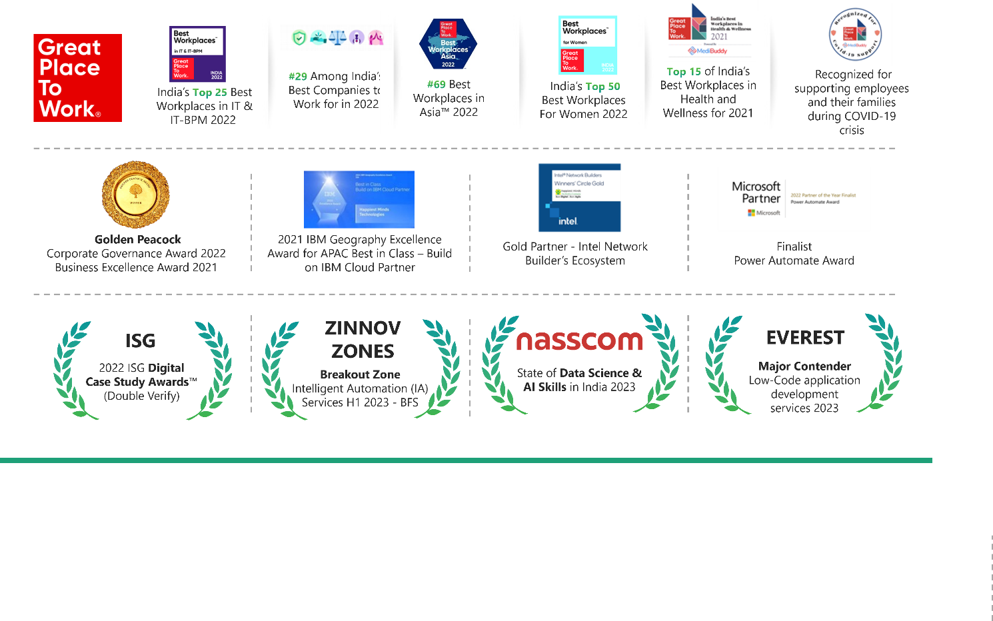

Our Business:

Our business is organized into the following three Business Units (BUs):

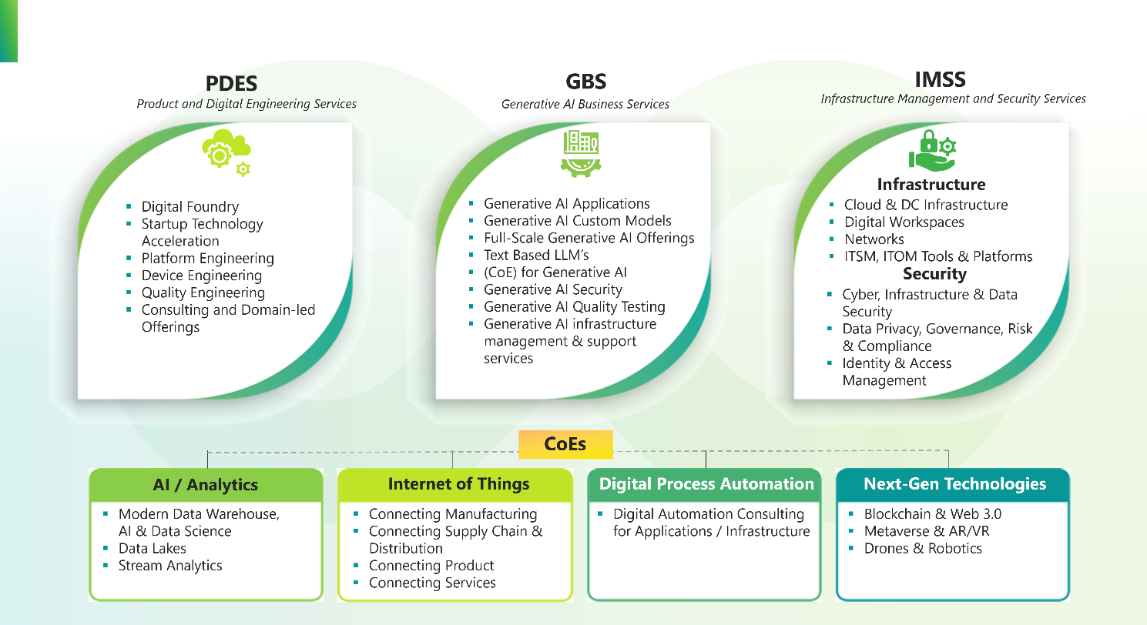

Product & Digital Engineering Services (PDES):

Our PDES BU aims to help our customers capitalize on the transformative potential of ‘digital’ by building products and platforms that are smart, secure, and connected. We provide our customers, a blend of hardware and embedded software knowledge which combines with our software platform engineering skills to help create high quality, scalable and secure solutions. We get our clients started on this journey with our digital foundry that allows us to build rapid prototypes for our customers and provide a scalable Minimum Viable Product (MVP). We embrace a cloud and a mobile friendly approach along with an agile model that is supported by test automation to help our clients accelerate their time to market and build a competitive advantage.

We engineer next-generation products and platforms across software and hardware that provide **end-to-end engineering services** for developing **high-quality, scalable, secure, and connected products**.

We have expertise in **core technologies** (cloud, mobile UI/UX, hardware & embedded, DevOps) and **emerging technologies** (blockchain, AI, edge computing, drones, and computer vision) across edutech, hi-tech, media and entertainment, healthcare & life sciences, industry, and manufacturing sectors. These provide us with a competitive advantage and have enabled us to build smart and connected product solutions and services. Despite a competitive landscape, it is our expertise in digital technologies, engineering innovation and customer centricity that make us a preferred partner of our clients.

Generative AI Business Services (GBS):

Generative AI is becoming increasingly essential in today’s digital age due to its significant impact on business operations. It revolutionizes how organizations access information, drive innovation, enhance efficiency, and facilitate reasoning and problem-solving. Happiest Minds is at the forefront of harnessing this transformative technology, empowering companies to stay ahead in a rapidly evolving digital landscape.

With our consulting, R&D, and testing capabilities, we assist in crafting a tailored roadmap for seamless technology integration, aligning with your specific objectives. We partner with you as your innovation enabler, aiding you to harness Generative AI to achieve quantifiable business goals.

Happiest Minds, as a technology partner, will help you create Generative AI-based solutions at various levels,

* For selective Process Automation, optimizing workflows for increased efficiency.
* To enhance existing solutions through additional features built on top of the existing systems.
* To engineer and implement completely new Generative AI-based solutions unique to your specific business challenges.

### 

Our Suite of Offerings enables businesses to harness the full potential of Generative AI.

* **Consulting**: Our consulting services are designed to guide our clients on their journey with Generative AI. We assist in setting up a Center of Excellence (CoE) for Generative AI, empowering organizations to become leaders in AI innovation with the right governance and structure. Additionally, we collaborate to define a comprehensive solution roadmap, ensuring that Generative AI addition aligns with our clients’ specific objectives and business strategies.
* **Engineering**: We extend our expertise through dedicated R&D teams. These teams are specialized in co-engineering, developing, and customizing Generative AI solutions tailored to your specific business requirements. Partnering with us, you gain access to an extensive pool of experienced engineers who can seamlessly add and integrate Generative AI into your products and solutions.
* **Testing**: We offer testing services that cover model and quality testing using automation to ensure that Generative AI models are accurate and dependable. Security testing is an integral part of our services, ensuring the utmost protection for your solutions against potential threats.
* **Infrastructure Management & Support**: We provide full infrastructure management and support services, making sure your Generative AI systems run smoothly. Our experts oversee all aspects of the infrastructure, from provisioning and scaling to maintenance, allowing you to focus on your core business while we handle the technical complexities.

Our unique strength lies in blending content, data, and AI to architect solutions that resonate with today’s dynamic business landscape. By leveraging our profound domain knowledge, we ensure seamless delivery and top-tier results. Our Generative AI value chain is a collection of essential components that work together to unlock the full potential of this transformative technology.

* **Services**: We offer services that bring together AI applications and human expertise, as per your organization’s objectives and quality standards. We oversee, monitor, and fine-tune the solutions implemented, leveraging Generative AI capabilities to create scalable technology that helps you deliver business goals.
* **AI Applications**: We develop practical tools for specific purposes at Happiest Minds. These applications, driven by Generative AI models, solve real-world problems, improve user experiences, and automate tasks across different domains.
* **Custom Models**: We create customized models tailored to your needs. These models enable generating content, automating processes, or making predictions as per the unique requirements of individual organizations and industries, ensuring precision and relevance.

Infrastructure Management & Security Services (IMSS): Our IMSS offerings provide an end-to-end monitoring and management capability with secure ring fencing of our customers' applications and infrastructure. We provide continuous support and managed security services for mid-sized enterprises and technology companies. Specialized in automation of business and IT operations with DevSecOps model and with NOC/SOC, we strive to ensure that the data center, cloud infrastructure and applications are safe, secure, efficient, and productive.

Our security offerings include cyber and infrastructure security, governance, risk & compliance, data privacy and security, identity and access management and threat and vulnerability management.

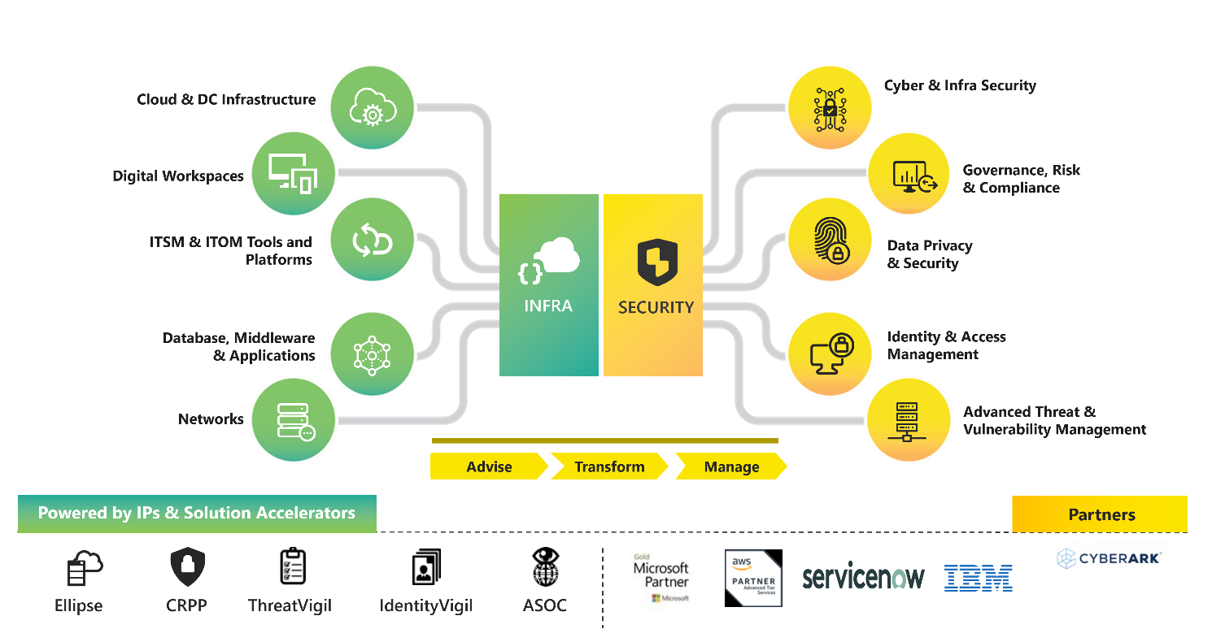

Our business units are further supported by the following **three Centers of Excellence (COEs)**:

* **Internet of Things (IoT):** Our IoT offering includes consulting led digital strategy creation, device/edge/platform engineering, end-to-end system integration on industry standard IoT platforms, IoT security, and IoT enabled managed services, implementing IoT roadmap, deriving insights from connecting assets, connecting manufacturing, supply chain, products and services to deliver IoT led business transformation and new business models aimed at enhancing our customers' operations and customer experience.
* **Analytics / Artificial Intelligence (AI):** Our analytics/AI offering includes implementation of advanced analytics using artificial intelligence, machine learning and statistical models, engineering big data platforms to deal with large volume of data, creating actionable insights with data warehousing, modernization of data infrastructure and process automation through AI.
* **Digital Process Automation (DPA):** Our DPA offering includes consulting led digital transformation through process automation of core business applications, products and infrastructure landscape of our customers, leveraging various intelligent process automation tools and technologies including Robotic Process Automation (RPA), intelligent business process management (iBPMS) and cognitive automation using AI & machine learning based models.

## Our Solutions & IPs

### AR, VR & MR

The digital revolution is well and truly here. The technology landscape has shape-shifted dramatically in the last few years due to the evolution of cloud, storage and processing coupled with the ubiquity of smart devices and the emergence of 5G. As a result, we are now in the middle of a paradigm shift in the way businesses engage with their customers by leveraging digital reality to create truly immersive experiences.

Enterprises are exploring innovative business models with AR, VR and MR serving as key enablers of digital initiatives that are meant to engage with customers and employees in an intuitive and personalized manner. With growing traction especially in the areas of training and remote collaboration, these technologies are creating a significant impact in verticals like manufacturing, healthcare, education, retail, media, and sports to name a few.

Happiest Minds with its deep expertise in the areas of 3D content design, computer vision, artificial intelligence and IoT is poised to help its clients create turnkey digital reality solutions that foster real time interactions and truly immersive experiences, including in the **Metaverse**.

### Blockchain

Happiest Minds brings in a deep understanding of the blockchain ecosystem to enable our customers to develop solutions and implement blockchain based solutions that help create incremental business value.

Using a consultative approach, we work together with organizations in understanding their unique requirements to advise our clients about the right technology, architecture, or algorithms to deploy for blockchain implementations.

We have enabled our clients to deploy blockchain based solutions across –

* Trust centric supply chain environments
* Network security and infrastructure configurations
* Smart contracts for peer-to-peer transactions in Fintech

Our services come with a strong focus on cyber security coupled with our core expertise in deploying and managing cloud and On-Premises IT infrastructures that form the building blocks of Blockchain Platform as a service.

We have done interesting work using Blockchain for customers in Edutech and in Luxury Retail. For instance, we leveraged blockchain to help universities with a reward management & certificate verification system where students earn rewards points that can be traded for various services. Our approach based on an Ethereum based blockchain network managed the program through smart contracts and enabled the transactions to be secure and tamper proof.

We also used blockchain as a key enabling technology for an e-commerce entity dealing in pre-owned luxury watches to transform the way vouchers were issued to their customers by making the process fully digital and redeemable across partner stores worldwide.

## Our Edtech domain expertise

Happiest Minds, right from the start had the unique opportunity to work with some of the marquee names in the Education vertical. Currently, Education technologies constitutes one of the largest verticals for the company with close to 800+ engineers, product managers, and business analysts working on engagements spread across multiple product lines. This has enabled technology consolidation and unification. Our engagements have had, and are continuing to have, strategic impact for our customers to accelerate their product roadmap, launch new products, modernize legacy applications, improve performance and reliability, transform business models, and incubate new ideas.

With laser focus in the education domain, we have been able to spread our presence in Higher education, K12, Early learning, Professional education, Exam preparation and Testing/assessments sub segments. This has helped us to graduate our focus to a fully blown industry vertical specifically dedicated for education.

On the teaching/learning side, we offer our experience in building technology platforms to make content engaging and interactive across various delivery medium and learning models. This helps EdTech companies to offer courses online, track learning behavior, monitor content consumption patterns, map contents to curriculums, enlist them in storefront, provide both synchronous and asynchronous teaching and learning, assess, grade, and certify Learners.

On the Administrative side of things, we offer our experience to build technology platforms to attract and recruit students /learners, automate workflows, better student engagement, reduce churn, modernize CRM, payments, billing, and other institution wide systems, enable cloud-based business intelligence /analytics platform.

While, our practices spanning across Microsoft, Open source and Java, Testing, DevOps, Analytics and IOT form the technology epicenters to serve our customers with right solutions. Off late, we have been focusing lot on immersive technology to emulate experiential learning, NLP based virtual tutoring, content curation, automated short answer grading - Machine learning models for deriving intelligence from large volumes of structured and unstructured data of student and courses as well as Deep learning for Adaptive assessment and content. Our experience working with EdTech companies and institutions has helped us to build solutions which transforms institutions from being data rich to information rich, by providing platform to collate data from multiple data sources and build intelligence & intelligent applications on top of it. Our IoT Center of Excellence teams along with customers are experimenting on using smart sensor technology to improve security, surveillance, wayfinding, smart dorms, and classroom to better campus experience for students. Our blockchain taskforce has started to do initial experiments on platforms like Blockchain to enable digital and micro credentials.

For all engagement with our education customers, we deploy team consisting of tech talent from practices, delivery manager who focus on engineering excellence and domain folks who bring the industry/product knowledge. With this team, we have been able to deliver lot of value in all our engagements, from test automation, performance, security testing, accelerated product development, re-engineering, modernization to new product innovation and business transformation. Some of the aspects of our value adds are listed as case studies / success stories.

In summary, Education is a core domain for Happiest Minds, and we have a strategic focus on this as a vertical. We constantly strive to bring in proven technology, experiment with new and emerging technologies and build competencies to solve critical problems for our customers. The impact we want to make is to reduce unit cost of education administration, better the teaching/learning experience and most importantly influence student outcomes. This impact that we make to education aligns very closely to ethos of the company and our Executive Chairman and Founder Mr. Ashok Soota.

Our Offerings in EdTech:

# Requirement Summary

## Overview

Aptech Assessment & Testing Solutions is a leading Assessments as a Service provider. Their service offerings cover the entire value chain and includes:

* Test Intimation/ promotion.
* Registration Portal for Applicant enrolment.
* Registration Fee Collection.
* Test Center selection and allocation.
* Question Item Authoring
* Assessment Creation, Scheduling and Roll-out.
* Supply of test centers on a pan-India basis with proctors.
* Assessment day event management – checking credentials of candidates, conducting the assessments, proctoring, etc.
* Publishing of assessment results
* Share Analytical reports on the assessment – item analysis.

Aptech’s current platform was developed more than a decade ago. They are looking to build a holistic assessment platform solution that would address the entire value chain.

REQUIREMENT DETAILS

|  |  |  |  |  |  |
| --- | --- | --- | --- | --- | --- |
| **S No** | **Phase** | **Module** | **Module Description** | **Sub Module** | **Required Output** |
| 1 | Pre | M1 | User Management | User Management | SystemAdmin, SME, Moderator, SAC User, Author, Proof Reader, Implementation, ATCAdmin, |
| Dashboard |
| 2 | Pre | M2 | Confidential Data Management (CDM) | Activity Logs | Activity logs of all Users and Servers for any activity (**C**reate **R**ead **U**pdate **D**elete) on any data or structure at Local / Cloud Server(s) |
| 3 | Pre | M2 | Confidential Data Management (CDM) | Content Creation | SMEs to create the Questions in Secure Environment |
| Software MUST support Multiple Languages |
| VPN based login with MAC & IP binding of Content Creators |
| 4 | Pre | M2 | Confidential Data Management (CDM) | Content Authoring | **Creation of Structure of Exam Console as per Client Requirements like:** i) Question & Option Shuffling ii) Multiple Sections iii) Section wise timer iv) Question wise timer |
| v) Multiple Parts in a single Assessment vi) Log Table & Calculator (Normal, Scientific) vii) Duration of Assessment (Automation for PH Candidates) |
| 5 | Pre | M2 | Confidential Data Management (CDM) | Content Type | **Software MUST be compatible with following type of Questions:** i) Multiple Choice Single Response ii) Multiple Choice Multiple Response iii) Fill In the Blanks iv) True or False |
| v) Match the Following vi) Reason - Assertion / Passgae Type vii) Video / GIF viii) Subjective Questions with Mathematical / Scientific / Chemical Formulae; response through Physical Keyboard ix) Numerical Ability Questions; response through On Screen Virtual Keyboard x) Memory Test Questions |
| 6 | Pre | M2 | Confidential Data Management (CDM) | Content Authoring | Conversion of Content into required format i.e., Excel or Images of Questions and Options |
| Uploading of Excel or Images into the system followed by immediate Encryption |
| 7 | Pre | M2 | Confidential Data Management (CDM) | Proof Reading | Proof Reading of mapped QPs by respective SMEs on the Console same as Exam Console to be displayed to the candidates with easy navigation across various questions and sections |
| 8 | Pre | M2 | Confidential Data Management (CDM) | Encryption & Locking | Encryption of Final Data and Lock by SAC User |
| 9 | Pre | M2 | Confidential Data Management (CDM) | Transfer | Secure automated Transfer of Encrypted Confidential Data from Local Authoring Server(s) to |
| Main Server |
| 10 | Pre | M3 | Application Development | Candidate Registration Portal | Development of Registration Portal for the Candidates to apply and Pay the fee through Automated Payment Gateway. Logs of each activity required along with User IP Address and timestamp |
| 11 | Pre | M3 | Application Development | Telephonic & Email Helpdesk | Helpdesk with logs of Calls & Emails Received. AI WhatsApp Support |
| 12 | Pre | M3 | Application Development | Dashboard | Monitoring Dashboard to trace the progress of Registration |
| 13 | Pre | M3 | Application Development | Test Center Management | Test Center Database with Unique TC Codes for Scheduling of Candidates, Tracing the |
| Readiness and Main Exam, Incident Management |
| 14 | Pre | M3 | Application Development | Candidate Scheduling | Roll Number Generation & Scheduling of candidates as per following inputs: i) Scheduling Logic (Randomized) as provided by Client ii) Capacity Available in each center and city |
| 15 | Pre | M3 | Application Development | Admit Card | Generation of Admit Cards & automated info to scheduled candidates through automated SMS/Email |
| Admit Cards should have Bar Code / QR Code for verification at the test center during Entry and Registration |
| 16 | Pre | M4 | Readiness | Dry Run / Mock for Test Centers | Automatic Generation of Dummy Ids / Mock Ids for a complete three day Dry Run at all scheduled centers as per the TC Codes |
| 17 | Pre | M4 | Readiness | Static Mock Link | Internet Based Mock link for Candidates' Practice with the Dry Run Question Paper and Live System Generated Credentials. It will be hosted on a Cloud Server so that candidates can practice 24x7 |
| 18 | Pre | M5 | Biometric Registration | Photo & Biometric | Capture the photograph and biometric of each candidate |
| Random Seat Generation |
| Provision for Aadhaar based Registration / Verification |
| Provision for AI based Verification |
| Candidate should NOT be able to START exam without getting registered unless bypassed from the Primary Server in critical / exceptional scenarios |
| Attendance Sheet Generation after Biometric Registration as per the Seat Numbers Generated |
| 19 | Pre | M6 | Conduct of Exam | Configuration of Test Center | Binding of Primary & Back up Server MAC Ids and VPN Ids with the Test Centers for |
| Server (Primary Server) | Confidential Data download with restrictions |
| 20 | Pre | M6 | Conduct of Exam | Configuration of Test Center | Download of Templates, Structure, Candidate Data on the Primary Server a day prior to the exam. Main Server should provide data only to the MAC / VPN Ids binded against a test center |
| Server (Primary Server) |
| 21 | Pre | M6 | Conduct of Exam | Configuration of Test Center | Mirroring of Important folders / Applications of Primary Server on the Back up Server for changeover in the event of failure of Primary Server |
| Server (Back up Server) |
| 22 | During | M6 | Conduct of Exam | Confidential Data Download | Encrypted Question Paper Download or Import at the ATC 30 to 45 minutes prior to the examination |
| 23 | During | M6 | Conduct of Exam | MAC Binding with Candidate Id | Candidate should be able to start the exam only at the pre-defined test node i.e., MAC Id & IP Address |
| Provision must be there to demap specific or all candidate ids if required |
| 24 | During | M6 | Conduct of Exam | Changes on the FLY | The Administrator (SS) must be able to make following changes to Candidate Data on the Primary Server during exam after providing a unique system generated Security Password: i) Addition of Candidate(s) ii) Increase / Decrease Time iii) Raise Incident against any or all candidate ids iv) Block any candidate id for Cheating/Unfair means |
| 25 | During | M6 | Conduct of Exam | Monitoring Console & Dashboard | Monitoring Console at each Primary Server to examine the real time feed / progress of exam |
| Centralized Dashboard to monitor the progress Pre, During and Post Exam activities of each |
| Primary Server / Test Center i.e., **ATC Configuration, QP Download & Generation,** |
| **Scheduled Count, Registered Count, First Login Count, START EXAM / Final Login Count,** |
| **Seat Mapping / Demapping, Submission, Other Security Alarms** |
| 26 | During | M6 | Exam Player | Exam Player | Exam Player software which would run on the test node through LAN Boot and MUST be independent of OS on the test node. Provision of exe file should be there which can run on all versions of Win & Linux OS |
| Once the test nodes connected to the Primary Server are Switched ON and respective Seat Number is Registered to Primary Server, it should start and execute the dry run automatically through unique Dummy Ids without manual intervention |
| **For Main Exam, candidate will manually input the credentials** |
| Every click of Mouse must be recorded in Audit Logs with Timestamp |
| 27 | During | M6 | Exam Player | Exam Player | Exam Player MUST be completely secure, should bind the peripherals of the test node (keyboard, mouse, hard disk, RAM etc.). Also the software Must block: |
| i) Internet via all modes - Ethernet, Wi-Fi, USB / Hotspot Tethering, Bluetooth ii) Remote Software’s iii) Screen Recording Software’s iv) Virtual Machines v) Multiple Login vi) Keyboard vii) USB Storage Device - PEN Drive & HDD viii) Multiple Screens / Displays ix) AMT / IME |
| x) KVM Switch |
| 28 | During | M6 | Exam Player | Remote Proctoring | i)               Desktop / laptop will be in locked mode, no pen drive, dual display monitors, will be allowed. |
| ii)              A student can only see the exam screen, they cannot visit any other site till the exam is completed. |
| iii)             Blocked Remote Access) Photo Verification before and during the exam (at regular intervals) v) Third party body / face detection during exam vi) Third party / Alien body and face detection during exam vii) Third party voice detection during exam |
| 29 | During | M6 | Exam Player | Exam Console | The Exam Console MUST display the following: |
| i) Candidate Details along with Application & Registration Photograph ii) Timer iii) Client & Exam Details iv) Question Palette for Color Blind v) Watermark vi) Test Progress Bar vii) NEXT, PREVIOUS, MARK FOR REVIEW (FLAG), CLEAR RESPONSE Buttons viii) Zoom in / Zoom Out ix) Question Toggle |
| x) Log Table / Calculator |
| 30 | During | M6 | Exam Player | Candidate Responses | Hashing of Candidate Responses with print / email facility |
| 31 | During | M6 | Exam Player | Candidate Feedback | After Submission candidate will submit Feedback on some pre-defined questions |
| 32 | Post | M7 | Candidate Exam Data & Logs | Candidate Responses | Syncing of candidate response data from each test center to the main server. |
| Once the exam is completed the SS should be able to upload the candidate response data along with Audit Logs to the Main Server. |
| Provision to download these data files on local servers in case the same needs to handed over to the Client observer present at each center |
| **Response Data should be free from any errors / deviations** |
| 33 | Post | M7 | Candidate Response Data & Logs | Consolidation | Automated Consolidation of Candidate Response Data into Single Database for submission to the Client within 3 hours of completion of exams. **NO MANUAL INTERVENTION** |
| 34 | Post | M8 | Objection Tracker | Interim Answer Key | SMEs to punch the Interim Answer keys |
| 35 | Post | M8 | Objection Tracker | Response Sheet | Response Sheet generation of all candidates in the form of HTML based on their own and |
| Interim Answer Keys |
| 36 | Post | M8 | Objection Tracker | Raising of Objections | Portal for the Candidates to raise Objections (if any) to the Interim Answer keys and pay required fee through Payment Gateway |
| 37 | Post | M8 | Objection Tracker | Objection Consolidation | Consolidated Unique Objections to be sent to the respective SMEs for evaluation and punching |
| Final Answer Keys |
| 38 | Post | M9 | Result Processing | Raw Score Evaluation | Raw Scores will be generated for all present candidates as per the logic provided by the Client and Final Answer Keys provided by SMEs |
| 39 | Post | M9 | Result Processing | Merit List | Merit List Generation as per the Logic shared by Client |

## In Scope

1. Requirement Documentation (Epics and Stories)
2. Design and Development of Assessment Platform
3. User Experience (UX) (limited to custom features))
4. Functional Testing (Manual)
5. Performance Testing (8 key services)
6. Application Security Testing (OWASP Top 10)
7. Provide support for setup and automate the Infrastructure and CI/CD pipeline on AWS cloud for 3 environments - Dev, Testing, Staging and Prod environments.
8. Knowledge Transition is limited to System Architecture, Database Schema and new microservices codebase.
9. Set up CI/CD pipeline for build, test, store, deploy automations
10. Containerize applications using Docker and deploy on EKS
11. Integrate security and compliance checks in pipeline
12. Monitor deployments and integrate alerting
13. Warranty Support (2 weeks)
14. Language Support – English only

## Out of Scope

1. Any deviations from the mentioned features / requirements above.
2. Security scanning, IaC scans, artifact scans, Container scanning at various stages.
3. Pipeline Compliance evaluation & maturity assessments.
4. Test automation (UI and API)
5. PEN testing
6. Infrastructure Automation Script
7. Accessibility Implementation and Testing
8. Data migration – Both transactional and assessment content
9. User manual, SOP, Runbook Documentation
10. Any tool/ third party integration other than mentioned on the requirement section
11. Any features not mentioned in the above requirement details section

## Assumptions

1. Separate deployment of Candidate Registration UI portal with a specific domain name for different Organization events.
2. Only online candidate registration has been considered in the scope. No offline registrations.
3. Existing Question content can be extracted as QTI package for content migration.
4. TAO UI will be used as-is with skin change for the off-shelf components.
5. For the payment integration, only RazorPay will be considered.
6. Only MCQ based question are supported. No descriptive type questions.

## Dependencies

|  |  |
| --- | --- |
| Dependency on Aptech | To be available by |
| Product owner for any clarification | Start of the project |
| AWS Account for application setup and CI/CD pipeline | Start of the project |
| Git Repo, JIRA | Start of the project |
| Review UAT Test Case document | Start of the project |
| Availability of product team for UAT | UAT |
| Response to Happiest Minds’ queries within two business days. Any delays in response might have an impact on the effort and schedule & will be treated as a Change Request | During the project |
| Feedback on the deliverables for each milestone must be provided within 3 days of the delivery by Happiest Minds, else, they shall be deemed accepted | During the project |
| SMS & WhatsApp message templates | During the project |

# SOLUTION DESIGN & APPROACH

Our approach to build Aptech’s Assessment Platform is based on the following Guiding and Design principles.

## Guiding Principles

* **Assessment Centric**: Assessment is the primary feature of the platform. Platform enables features to author/upload of question items, create and publish assessments. The assessments created in a centralized server are portable to Test center based local server environments. The portability of the assessment is enabled with packaging and package deployment features.
* **Secured Assessment**: The assessment needs to be leak proof. The assessment is locked/secured by encrypting the question items and encrypting each candidate response. The access to locked assessment is provided only to authorized personnel based on their role and with a specific access key. Assessment delivery to candidates is authorized based on the MAC address of the terminal at the Test Center allotted for the candidate.
* **Operation Efficiency**: Platform is architected based on a cloud native and scalable approach. Ease of Test Center deployment, following the methodology as that of cloud deployment using the same deployment scripts.

## Design Principles

* **Microservices architecture with API first approach**. The API first approach enables standard way of defining and publishing API contract to client applications.
* **Cloud native design** enables the platform to run on a cloud infrastructure leveraging the managed services of the cloud platform.
* **Platform data is secured both at rest and transit**. All communications are secured through secured communication protocols, authentication, and authentication features.
* Microservices architecture with Cloud native design enables the platform to be **scalable, reliable, and maintainable**.
* Assessments and Questions are built using **QTI (Question Tool Interoperability) standards**.
* Single platform architecture caters for **both Online and Test Center based exams**.

## Reference Architecture

Aptech Assessment platform reference architecture is depicted in the below diagram. Single platform architecture that covers both the perimeters of Central Server and Test Center Server. The platform is built on microservices architecture, with multiple microservices for different modules of the assessment. For better implementation budget and faster time to market, the assessment platform is proposed to **build on open-source assessment platform TAO from Open Assessment Technologies**.

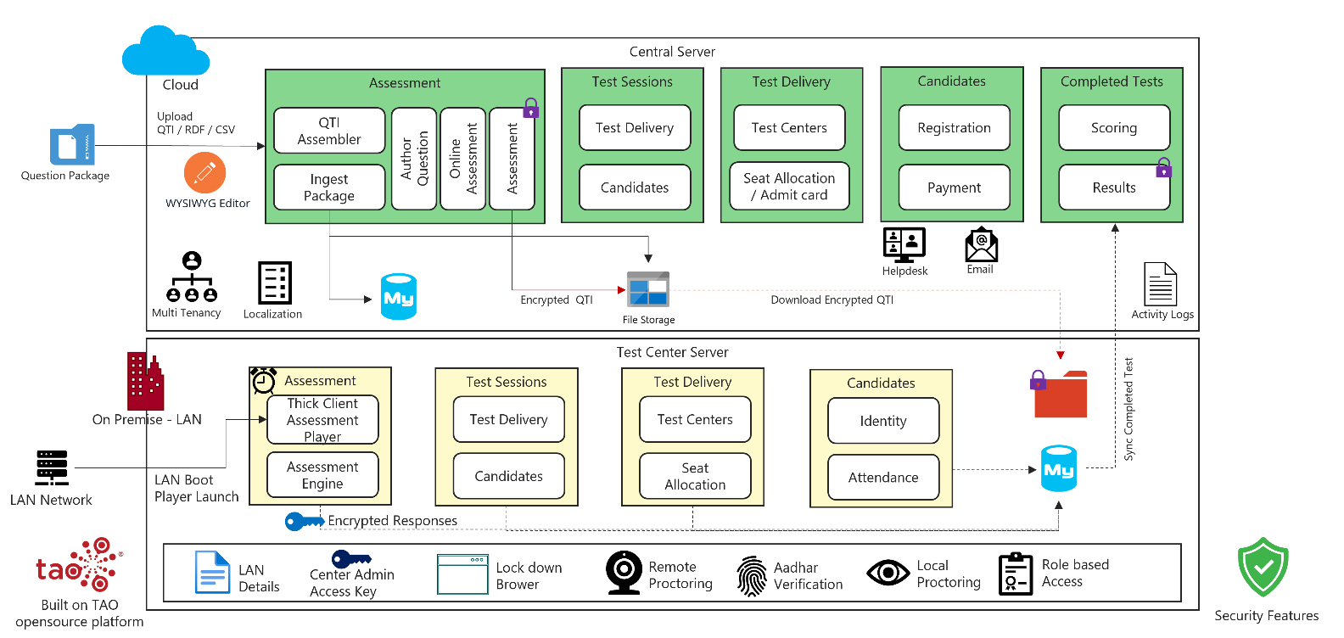

### TAO – Open-source assessment platform

TAO is a modern and robust assessment platform. It enables us to build accessible assessments. TAO supports various capabilities such as:

* Test Authoring
* Rostering & Delivery
* Results & Reporting
* Automatic & Manual Scoring

Custom module: Few of the Aptech requirements needs to be custom built on top of TAO architecture. TAO architecture is an extension architecture. Custom features can be built as a separate extension module. The extension module is structured as model, view, api and data. The extension can be built, tested and deployed independently. TAO has an extension manager to install new extensions into the core platform.

### Central Server

* Assessment Service: In an Assessment Service, question authoring and delivering is the primary capability. Assessments and Questions in the platform are based on QTI standard. The questions can be authored using the UI based authoring tool with WYSIWYG Editor. Also, questions and assessments can be uploaded either as QTI or RDF or CSV packages. The uploaded package will be parsed, and the file content will be stored in a cloud file storage, the metadata information will be stored in a relational database.

Using the assessment builder, authorized people can create an assessment with assessment policies such as Timed assessment, scheduled, practice or exam. The assessment author pulls in the questions from the question bank into the assessment though the UI based assessment builder. Post review of exam assessments by the authorized people, it is locked with an encryption key and stored in an encrypted format. The assessments are encrypted using symmetric key and stored in cloud key store.

* Test Sessions Service: The exam assessments are delivered through a Test session. The Test session is an event such as an entrance exam of a university or institution or course admission. The Test session will be created with a schedule of start and end dates. The locked exam assessment will be mapped to the Test Session. The candidates can register for a Test session through the registration portal. The registered candidates are automatically mapped to the Test Session.
* Test Delivery Service: The Test Sessions are delivered at various Test Center through Test Delivery mechanism. Test Center is created and managed through the Test Delivery module. Seat allocation process is done for all the registered candidates based on the Test Center preferences. The Test Session also will be mapped to the Test Delivery for an event. A QR code-based admission card can be generated for the registered candidates.

**QR Code Generation**

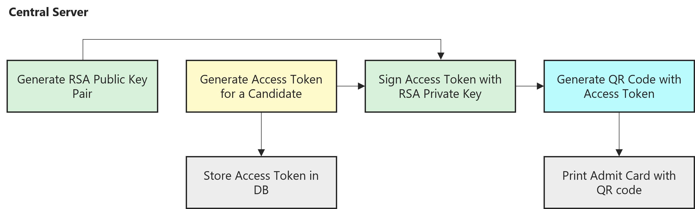

Physical proctors are managed in the platform for each Test session. Assessments are delivered to candidates during the exam schedule through a lock down window-based assessment player. The platform agnostic thick client player renders the web UI based assessment delivery screen in a cross browser embedded in the thick client player. Different set of Question paper and different order of questions will be delivered to each candidate. The candidate identity is verified through Aadhar integrated fingerprint verification, Physical verification of photo in the ID card. The candidate authorization to the assessment is using the QR code verification in the admit card and MAC address binding with candidates and their assessments. The question responses of each candidate are stored in an encrypted format using an encryption key. Only authorized people using the encrypted key can access the locked responses.

Candidates Service: Candidates appearing for a test event/exam can register through a registration portal. Exam fees can be paid by the candidate using the payment gateway integration. The registration portal branding can be applied for each event. Branding for a specific event is by building new CSS and publish the CSS to the portal.

* Test results Service: The candidate responses are evaluated using automatic scoring by scoring engine or manually depending on the assessment scoring settings. The score can be calculated based on ratio of correct and incorrect answers or just a pass or fail. The results list for candidates will be viewed based on each Test delivery. The test results for a Test delivery can be exported as a CSV file.

* Other Capabilities:
  + Multi Tenancy – Platform supports multi tenancy with each institution or organization conducting the Test session as different tenants. The tenants are segregated logically based on the tenant id in the common database.
  + Localization – Platform supports localizing the resources bundles for various languages. The localized resource bundles will be published to locale folders of the resource bundle.
  + Communication – Platform has integration with email, SMS and WhatsApp for notifications to candidates.
  + Audit – Platform creates and logs each activity of the authors and candidates as audit logs. The logs will be stored in audit tables with categorization of module and entity.
  + Data Store - The content metadata and transactional data are stored in a relational database. The file content of QTI package is stored in cloud file storage.

### Test Center Server

The Assessment platform can be deployed on a Test Center server same as that of Central server on the cloud using the same deployment scripts. The symmetric keys from cloud key storage has also been downloaded and stored in server key store. On connecting the Test Center Server into the Test Center LAN, the exam assessment is downloaded from the Cloud server by the authorized people. Post downloading the question the internet connection is removed from the LAN. The authorized person has the access key which can be keyed into the local server. Using this key the assessment is unlocked and decrypted using the symmetric key available in the server key store, before delivering the assessment to candidates. The assessment download process downloaded the QTI package for the exam assessment from Cloud file server and stored it into the local server file system to serve the files. The LAN environment is secured by applying the security policies on to each test node dynamically through the thick client assessment player. The thick client assessment player is launched through LAN boot of each test node.

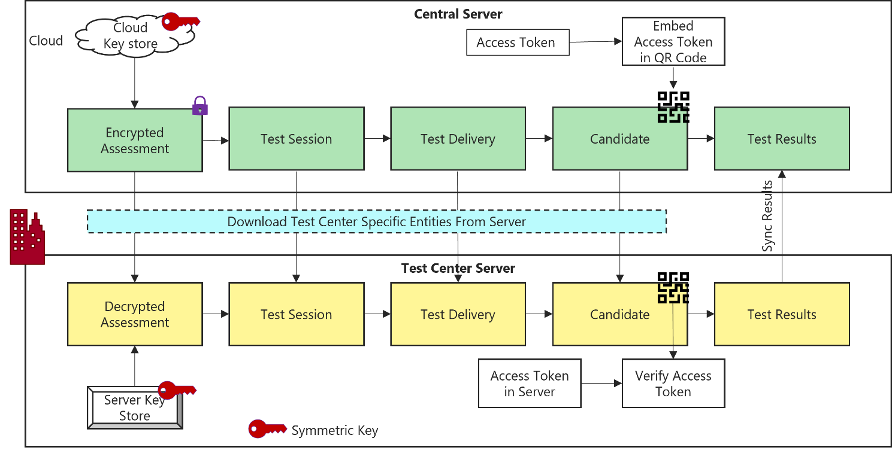

Candidate System Failure: For hardware issues, replace with new machines which are kept as standby. The Center administrator has the privilege to update the MAC address authorization for that candidate. Each question is served from the server to render in the assessment player. Similarly, each response submission by the candidate is sent to the server from the assessment player. After resuming from any disruption, the candidate can be able to resume the assessment where he left.

## Thick Client Assessment Player

The Thick Client Assessment Player is built based on Java for platform independence. The client player is only a container for a cross platform browser Equo Chromium. Equo Chromium, open-source component allows to render web UI in Java application container, with the best performance. Equo Chromium supports SWT (Standard Widget Toolkit). It can be embedded as an SWT control.

**LAN Boot**:

An option to boot the desktop/laptop connected from LAN in their BIOS or UEFI through PXE (Preboot Execution Environment). This process allows a computer to start up and load an operating system or other program directly from the LAN network.

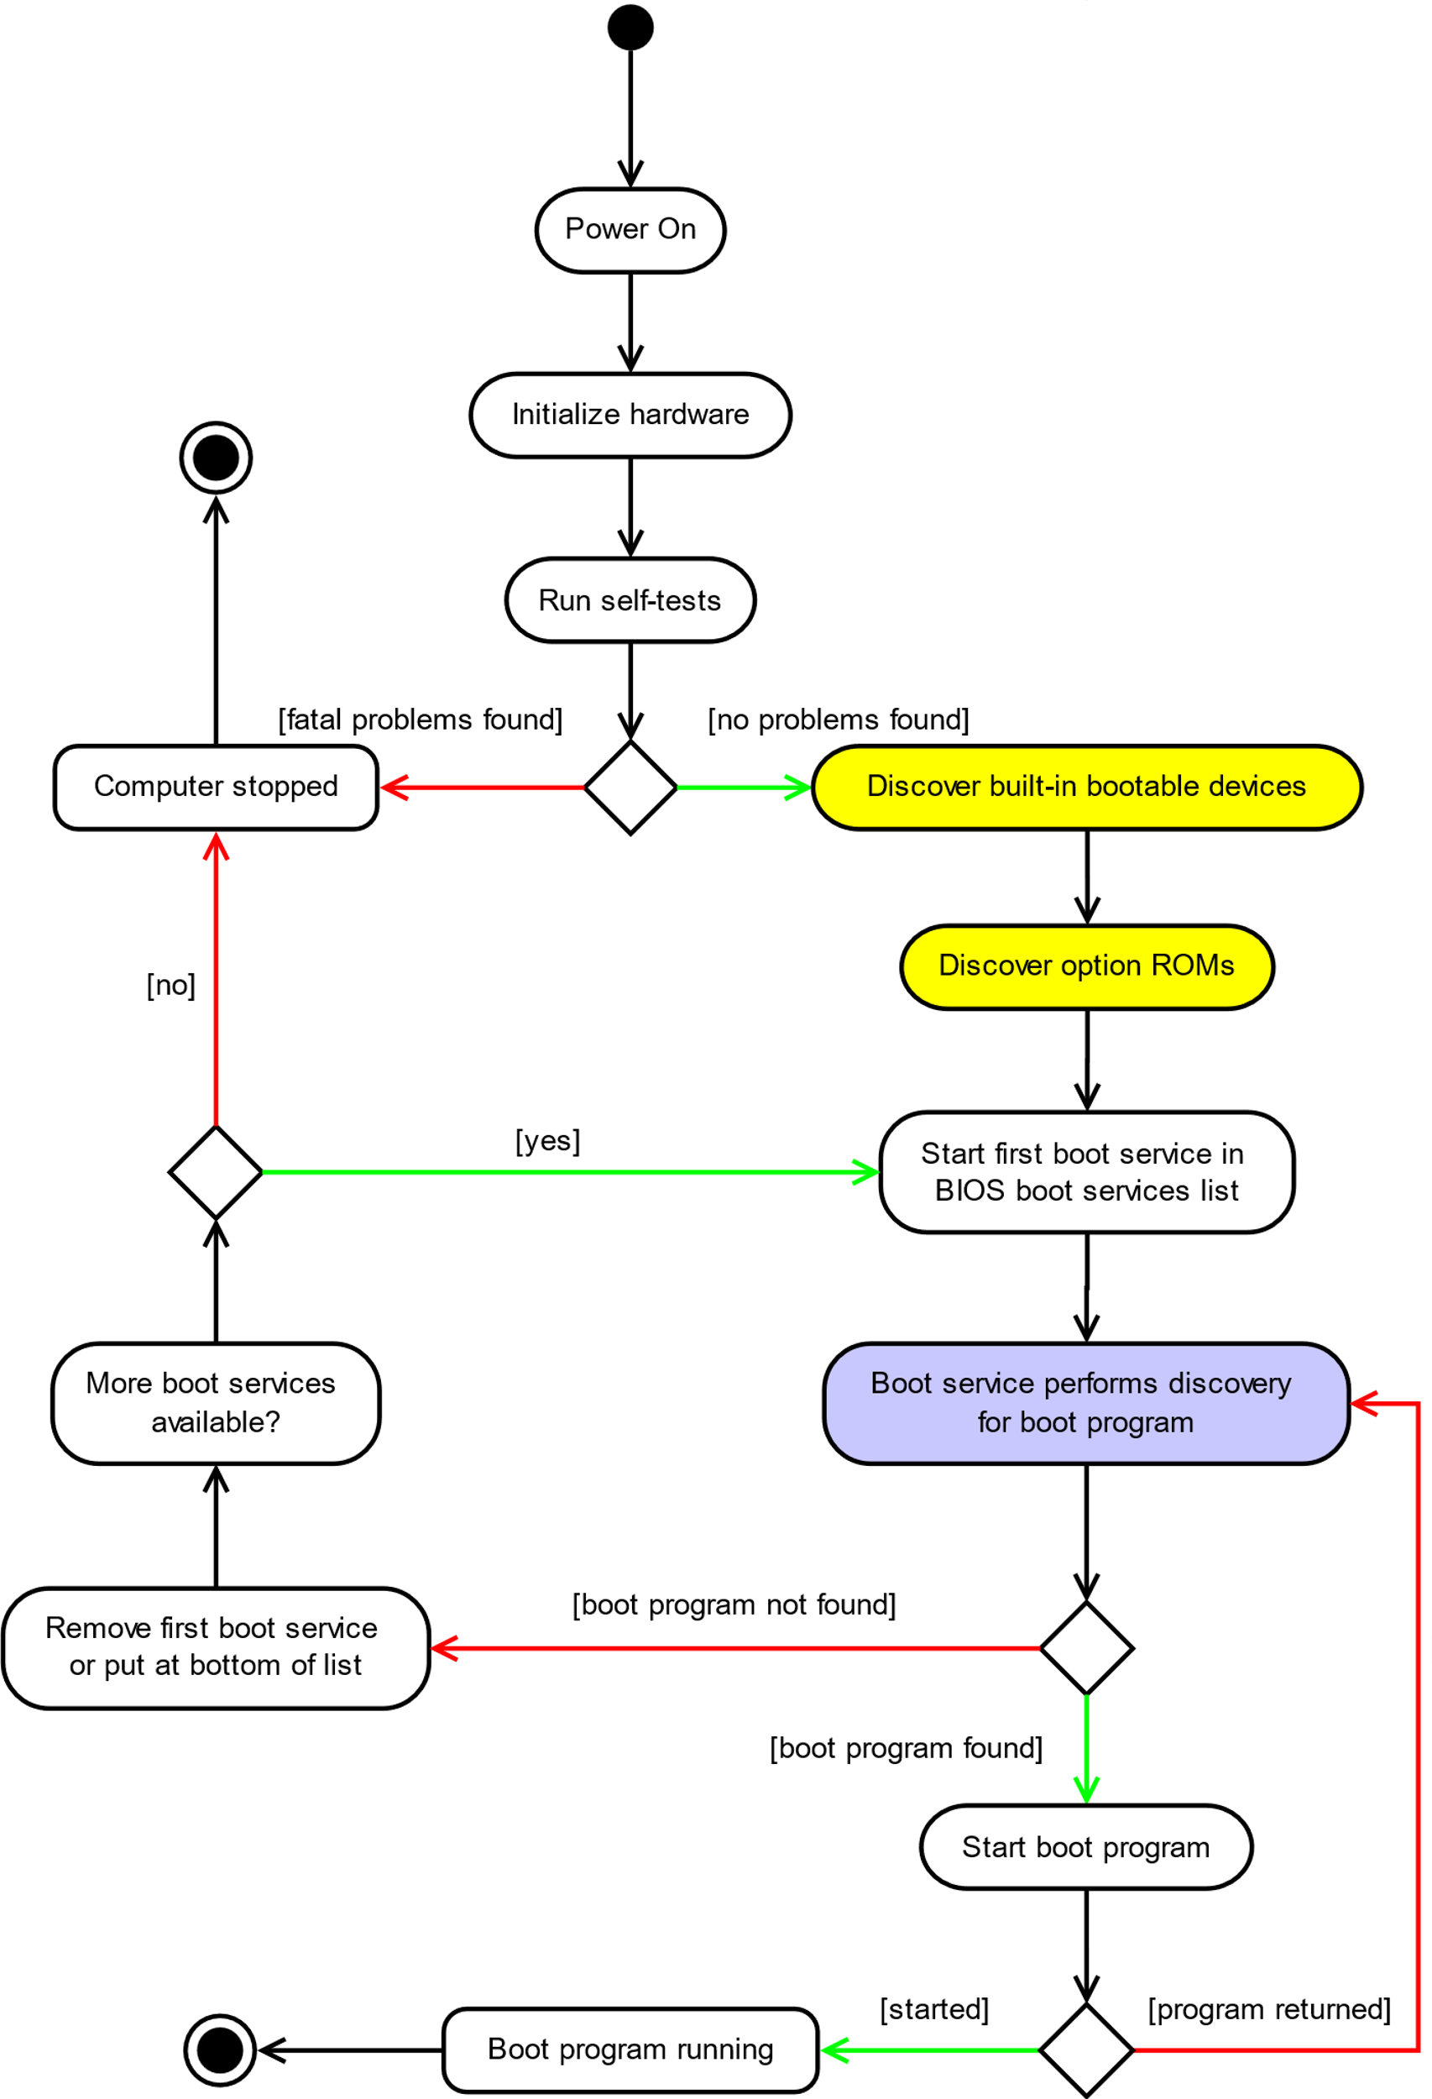

*Diagram from: https://networkboot.org/*

Push Thick Client Assessment Player to client machines on boot from LAN in their BIOS or through PXE. Using DHCP, Boot service downloads the Boot program (Thick Client Assessment Player). Thick Client takes full control over the computer, applies all the device restrictions using the dynamic security policy bundled with the client application. Thick Client keeps monitoring the security policies on all the device and internet ports during the exam. Any breach of the security policy will send an alert to local server on the monitoring UI and locks the assessment player in further access by the candidate.

**QR Code Verification**

The admit card has the QR Code with embedded access token. The Access token embedded in the QR code is verified at the Test Center. On verification of the access token the candidate is granted access to the assessment.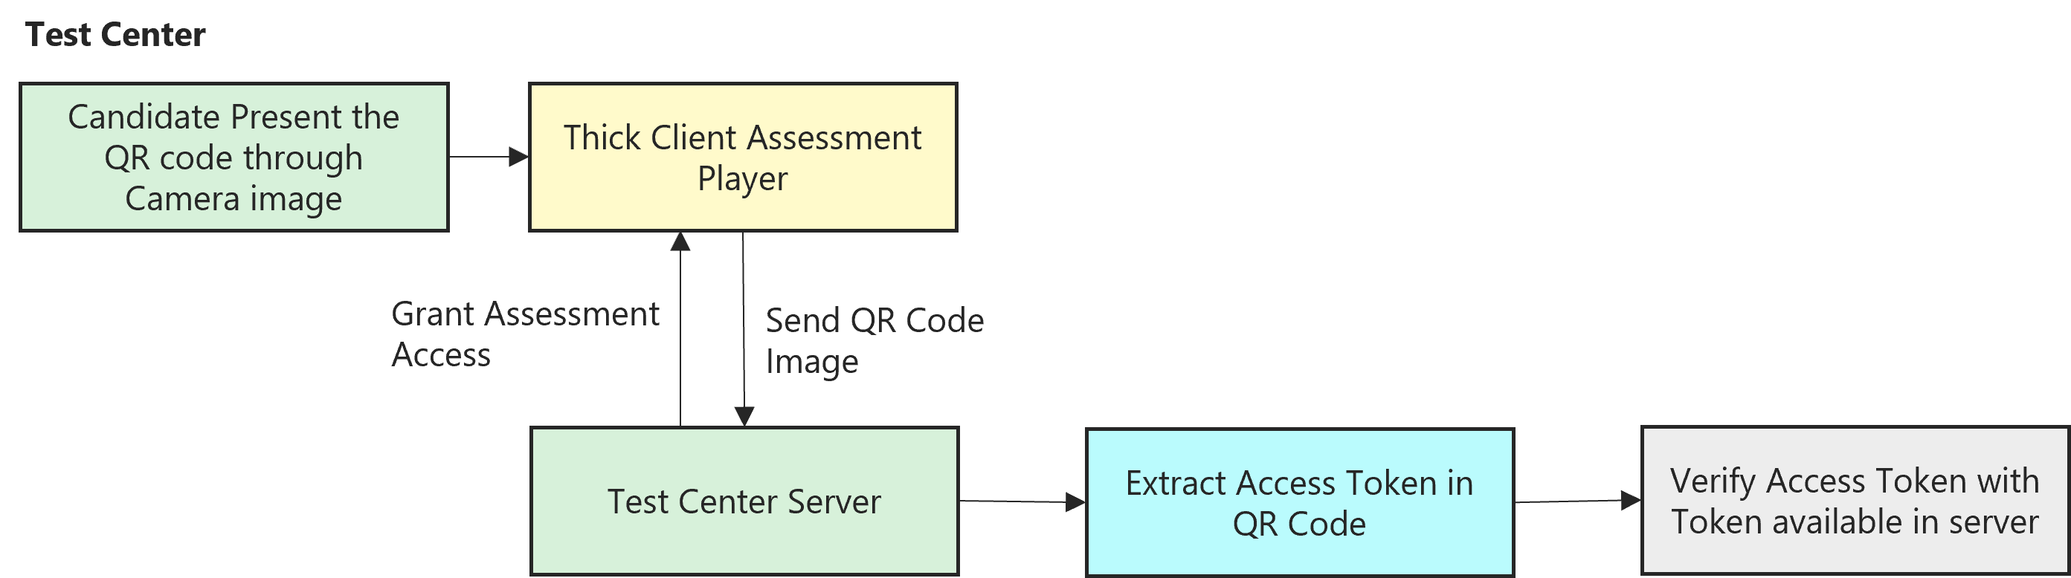

At the Test Center, candidates present the QR code camera image. Thick Client Assessment player provides the access to camera. The QR code image captured through the camera is sent to the local server for verification. The server extracts the access token embedded in the QR code. The extracted access token is verified against the access token available in the server. While validating the access token, the MAC address of the desktop also gets validated against the MAC address assigned to the candidate in the server. On successful token verification and MAC address verification, the candidate is granted access to the assessment.

## Security Considerations

* Encrypted Assessment package. Admin decrypts the package for delivery.
* Proctor Approval - Proctor publishes the assessment to each candidate post Identity verification. Candidate assessment entity gets created on publish.
* QR Code – Signed access token embedded in QR code and printed in Admit Card. Access token in QR code is verified against the access token available in the server.
* Anti-Impersonation – Facial recognition & Biometric using Aadhar verification.
* Offline Exam - Exam Center with machines preconfigured with static security policy with access restrictions to various ports and device drivers.
* Encrypted Candidate assessment responses
* Thick client Assessment player on the candidate devices provides dynamic security policies, VPN connection, restriction to ports and access,, tracking user activities, heartbeat and automatic reconnect to server on network failure.

## Performance Considerations

* Tao is of PHP framework, uses PHP-FPM (FastCGI Process Manager) for high performance with large concurrent access.
* PHP-FPM manages concurrent requests using child worker threads spawned for each worker process in NGINX.
* NGINX serves as the web server for Tao PHP application.
* A single server with the following configuration will be able to support 250 – 300 concurrent users.
  + Server configuration:
    - 4 Cores
    - 64 GB RAM
  + NGINX Configuration
    - 4 worker process (for 4 cores)
    - 1000 worker connections (per core or per worker process)
    - Total of 4000 worker connections

## TAO – Aptech: Feature capability matrix

The following table lists the feature sets that are available out-of-the-box in TAO and those that need to be built as custom module.

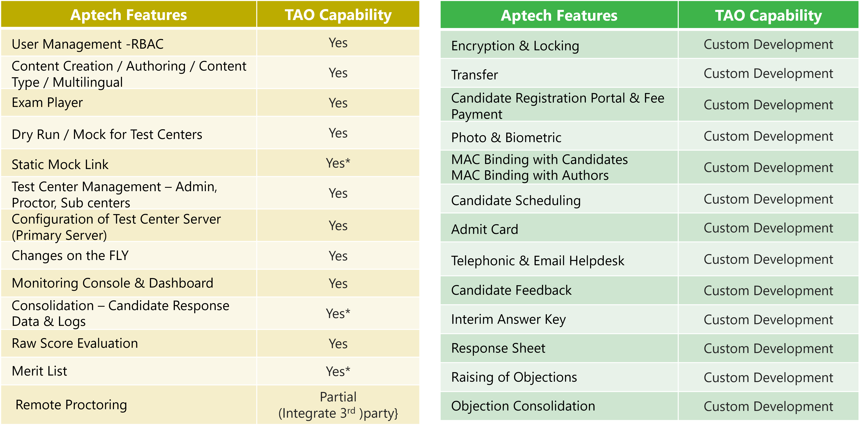

Note: * denotes features available in TAO but may require customization to support Aptech requirements.

## Local Deployment Architecture – Test Center server

The Test Center Server deployment consists of an active-passive cluster running on a Raid server. The setup consists of switches, Firewalls and Server cluster on Raid server. The communication between the LAN server and Cloud server is over a secured IPSec Tunnel.

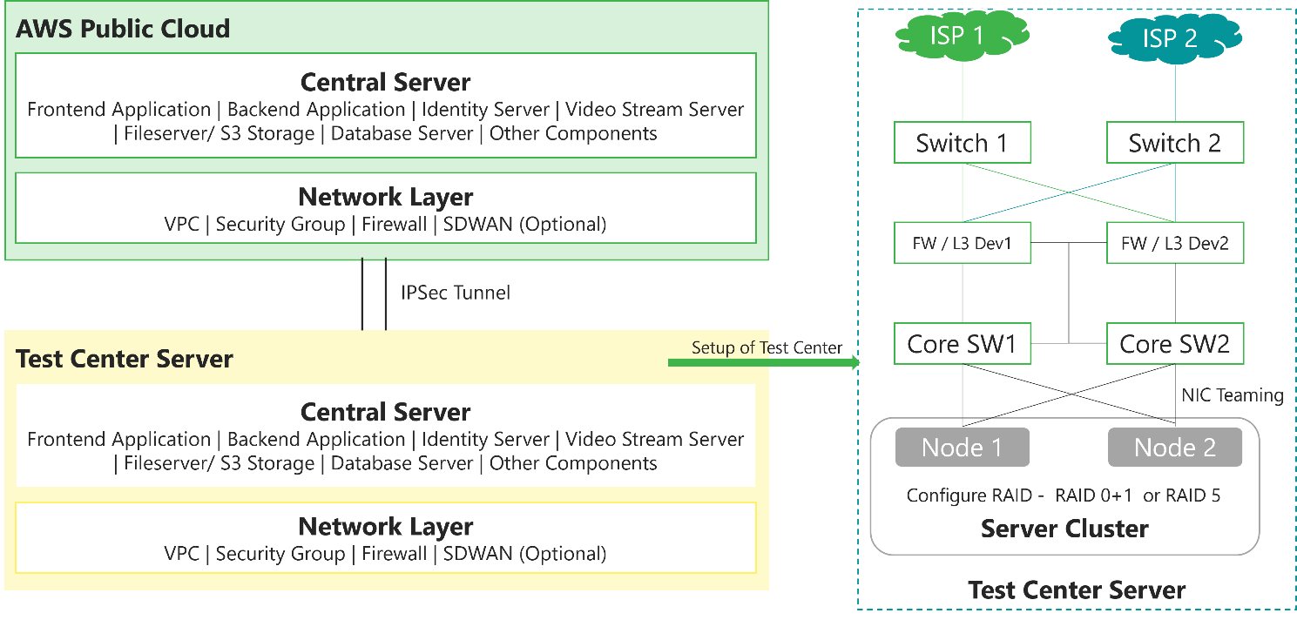

## Cloud Deployment Architecture – Central server

The application is deployed as Kubernetes container clusters from Container Registry. The MySQL RDS service is used as the data store and cloud managed Elastic cache as cache service. The UI components are stored in S3 and served over Cloud front.

## Future proofing the platform

* AI based assessment authoring.
* Semantic search to understand the distribution patterns of question.
* AI for Adaptive assessment.
* Assessment engine for assessment driven learning models.
* Support for Linear-on-the-fly testing.
* Automated grading for descriptive answers.

## **Proposed DevOps Approach**

## **Deployment Architecture**

The proposed deployment architecture is integrated with the Kubernetes (AWS Elastic Kubernetes service) platform. The Continuous Integration and Continuous Deployment being configured either with the proposed tools or with the existing tools. The services are isolated and deployed in the specific namespace in AWS account.

The diagram below and the tables gives the details about the tool's integration.

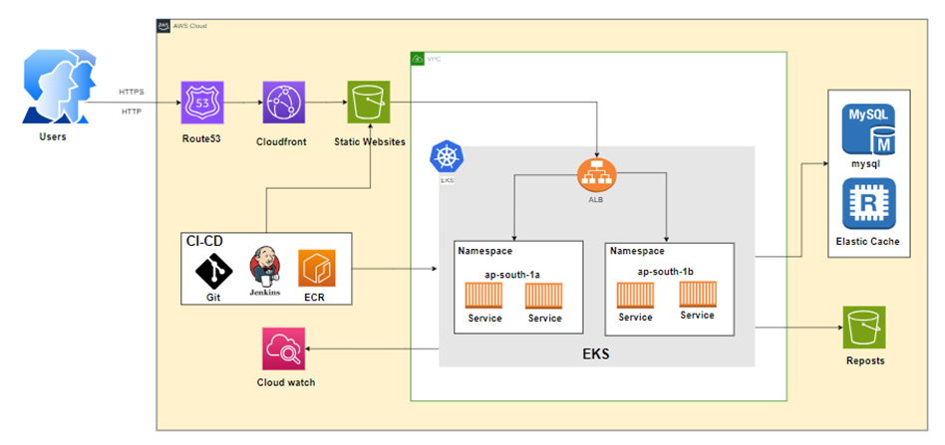

|  |  |
| --- | --- |
| **Tools** | **Description** |
| Elastic Kubernetes Service | EKS managed cluster is distributed across the region with High Availability, Autoscaling will be configured as part of the replica. |
| Elastic Container Registry | Base images are created for the containers to be deployed on EKS. We need centralized storage for configuring and uploading the non-prod and prod environments. |
| Cloud Watch | This is centralized and configured in the region for extracting and maintaining the logs. |
| AWS Elastic Cache for Redis | Create cross-Region read replica clusters for ElastiCache for Redis to enable low-latency reads.  Disaster recovery across AWS Regions. |
| CloudFront | CloudFront signed URLs provide a mechanism to control access to the content served through a distribution. |
| AWS S3 | S3 bucket can be used to host the static web application and to store the processed Documents and reports. |
| Route53 | Route 53 streamlines the setup of DNS routing by providing quick and easy domain name registration, complemented by straightforward visual traffic flow tools. |
| MySQL | MySQL is used to store data in tables that map to objects. Each table has a schema defining what columns each row of the table will have. |

**CI/CD Approach:**

Below is the proposed solution architecture/technology landscape to achieve DevOps CI-CD automation.

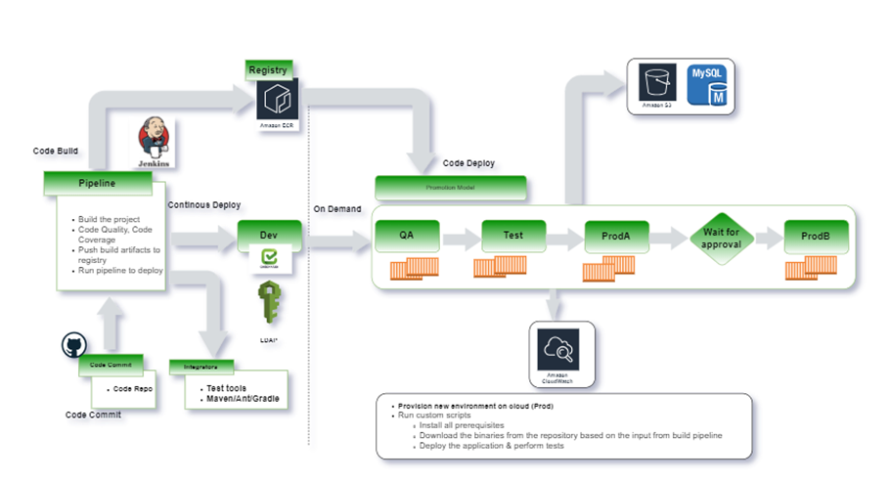

The following are the steps execution as part of the pipeline the CICD pipeline is configured with all the requirement stages for the build execution:

* CICD Pipeline is configured with a multi-stage build process for the pipeline build execution.
* Continuous Integration of the build process starts and triggers the staged build process.
* The triggered build process on the compilation is successful proceed with the next gated check with the code quality.
* During the process, the image is validated for all the security integration with the scanning using the tool.
* The image of having the vulnerability criteria falls into criteria like high, medium, and low grouping.
* The rules are being set with the expectation for the code to be passed in and uploaded on to the Registry.
* On successful compilation the build is uploaded onto the Container Registry.
* The artifact is then called using the Continuous Integration process for the artifact deployment onto the K8 cluster.

**Release process**

* The releases are done using the templates configured with the chart for the specific repos and the same can be reused across the board. The releases are version controlled and the rollback can be done at any point in time.
* All the artifacts are stored on the Container Repo and tagged with the defined labels.
* The promotion model is being set so that the same artifact can be promoted onto the next environment using the pipeline.
* Non-prod environment setup is done for doing their testing without disturbing any existing environment.
* Performance test scripts are integrated to run on the code deployed and validated.
* Alerts are being configured at all levels in case of failure to trigger so that they are completely monitored with the tools.

**Branching strategy**

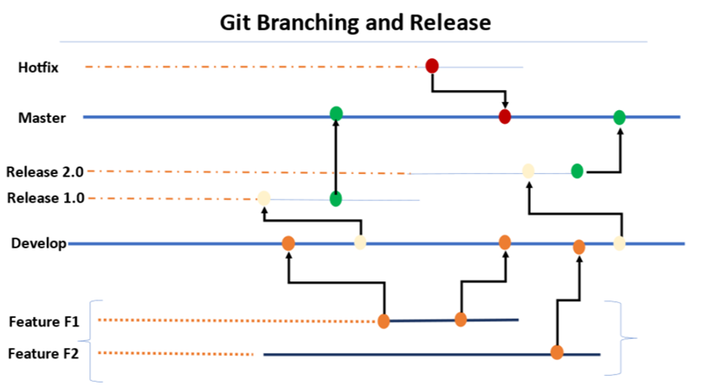

Proposed Flow:

* Standard conventions are followed for the branching strategy so that the product is uniquely identified.
* The feature branches are short lived branches which are being developed and merged into the development branches.
* The development branches are then merged on to the supporting branches called the Release branches.
* Tags are being created from the branches to do the releases.
* The release is then tagged based on the short outcomes of the releases.
* Finally approved changes are being merged back into the Master branch and the deployment happens from this branch.
* The master branch is then again branched out for the latest changes in development/feature to worked upon by developers.

The hotfix branches are created in case of any critical issues to be fixed on the production release being done from the master branch.

Release Process

* The release process will be created with the managers & cab approval obtained prior to the releases.
* Release processes are defined with the CI/CD Integrated
* Deployment will be done through the build tool.
* Frequent branches and the tagging process will be created for the deployment.
* Release will be tagged and stored as a Tag in the Repo.
* Hotfix branches will be created during the process of any critical fixes that need to be part of the deployment.
* Communicate to the Stake holders on the release complete
* The Release will be deployed using the pipeline with the specific branching Tag created for the deployment.
* The Releases will be version controlled and deployed from the specific pipeline.
* The promotion of artifacts will be done using pipelines.

## DevOps Cloud Security for Application

* Security Virtual Private cloud will be configured.
* Security Rules for the private and public cloud configured.
* Access Identity and Management (IAM) Access Analyzer
* Key Management Service Integrated for encryption.
* S3 configuration and monitoring
* Security assessments on the firewall rules & configuration
* Access to the corresponding repos

**Cost-Effectiveness, High Availability, and Scalability:**

To achieve cost-effectiveness, high availability, and scalability, we will employ the following strategies:

* **AWS Auto Scaling**: EKS clusters can be configured with AWS Auto Scaling, allowing the cluster to scale horizontally based on demand and workload metrics.
* **Load Balancing**: We will utilize AWS Elastic Load Balancer (ELB) or AWS Application Load Balancer (ALB) to distribute traffic across multiple instances of the microservices and React JS application, ensuring high availability and load distribution.
* **Cost Analysis:** Cost analysis will be performed to optimize expenses while maintaining a highly available and scalable architecture. This includes right-sizing EC2 instances, using spot instances for non-critical workloads, leveraging reserved instances for cost savings, and utilizing auto-scaling features to match resource usage to demand.

## Testing and Validation

Below is the test strategy that would be followed in identifying all the test scenarios to ensure enough test coverage. This also details on the test execution.

* **User Scenario Analysis:** We would be analyzing various user scenarios based on how various users who would be using the features as mentioned in Functional Requirement section like System Admin, SME, Moderator, SAC User, Author, Proofreader, Implementation, ATC Admin and design the end-to-end test scenarios to have good test coverage.
* **Application Scenario Analysis:** We would be analyzing the business requirements and would design test scenarios to cover all the modules (User Management, CDM, Application Development, Readiness, Biometric Registration, Conduct of Exam, Exam Player, Candidate Exam Data & Logs and Object Tracker and Result Processing) and sub-modules wherever the data would be flowing. Impact analysis would be conducted to understand the impact of developed functionality to the overall functionality and regression testing would be performed on the impacted features. Features that will be covered as part of regression will be shared in the Test plan with Aptech stakeholders.
* **Test Cases Design:** Test cases would be designed elaborating the Test scenarios identified from the previous 2 steps. Test cases would be prioritized as P1, P2 based on the criticality of the test case.
  + We would be documenting detailed test cases to be used for execution using the Test Scenarios identified from the previous steps. Test cases would be prioritized as P1, P2 based on the criticality of the test case.
  + P1 test cases include all the positive flow of a particular feature/requirement.
  + P2 test cases include negative flows to validate behavior and error/warning messages thrown by the application.
* **Test Execution & Defect Reporting:** 
  + Test Execution shall be planned at the sprint level and the end-to-end integration test level for every planned major and minor release. At least 2+1 Test cycles shall be planned for the identified test levels.
    - Cycle 1: First execution of the tests on a Build provided based on the scope identified. The defects shall be “mentioned in passing” with the developers. This will be before Transfer-to-Test. Focus shall be to help developers with the test cases and avoid leaking any defects to next levels.
    - Cycle 2: Full Regression with all the necessary integration points after transfer to tests. Report defects in a formal way in the identified defect management system and triage the same with all the identified stakeholders.
    - Cycle 2+1: Final regression on the build which is provided after all the accepted defects are fixed based on the triage meeting decisions.
  + A formal Build Certification Report shall be sent to all the identified stakeholders at the end of every test cycle executed.
* **UAT & Final Sign-Off**: Aptech would be performing the UAT and Happiest Minds shall be supporting Aptech during this phase. Defects identified in UAT would be discussed and prioritized with Aptech stakeholders. Agreed upon UAT defects would be fixed and validated before final signoff.

### Testing Types

### User Interface Testing

All the web application/Exam Player User Interfaces are to be tested as part of this testing. The focus areas of testing are:

* + - **Functional Flows**: Simulate different user behavior on the applications and validate the behavior of the application as per the requirements. (User Management, CDM, Application Development, Readiness, Biometric Registration, Conduct of Exam, Exam Player, Candidate Exam Data & Logs and Object Tracker and Result Processing)
    - **Layout Verification**: Verify every page in the web and mobile application to ensure that Layout, Elements and the look and feel are as per the requirements.
    - **Data Integrity**: Verify the correctness of Assessment Content that is displayed from the Cloud server to Test Center.
    - **UI Consistency**: Verify there are no broken links in the application and the successful rendering of the information based on the actions by the user. Verification will be done across all the web and mobile applications to ensure that the general UI guidelines like the logo, headers, footers, and other static information are available consistently across all the applications.
    - **Compatibility testing**:
      * Verification of web application will be done on the supported web browsers Chrome, and Edge with the latest and latest – 1 version. Full testing would be done on Chrome latest browser and sanity tests on all other supported browsers.
      * Validate Compatibility of Exam Player with different version of Windows and Linux OS

### API Testing

As part of the API testing the following are focused,

* All API end points are validated for CRUD operations with all the possible positive and negative test data.
* Perform data checks from the API Response.
* Check for Latency.
* Check proper Error Messages and Codes in case of failures and for negative validations.

### Integration Testing

Perform testing on the entire system as a whole interacting with different sub systems:

* Validate the integration with Tao System.
* Validate the Interactions to different parts of the system.
* Validate end to end data flow till the last system.
* Validate display of data on the dashboard getting from different sources mentioned in requirements.
* Validate the correct data has been transferred to the downstream /outbound system.
* Validate integration with Payment Gateway [Razor Pay]

### Performance Testing

The performance testing shall be carried out as per the identified performance requirements [Critical workflows, workload details, environment…] between Happiest Minds and Aptech teams.

* + Objective
    - Establish a benchmark for the identified workflows (in terms of Requests/sec, CPU load, concurrent users) for the web application and scenarios for agreed concurrent users.
    - To identify the scalability patterns and reliability aspects of the application.
    - To identify and fix any performance bottlenecks in the application.
    - To perform following performance tests to study the application behavior and its adherence to SLA.
      * Baseline performance test
      * Scalability tests
      * Reliability tests
* TEST APPROACH
  + - Happiest Minds performance testing team - will start with collection of requirements and identification of user workflows for the web application.
    - Perform a Tool fitment exercise to identify the right set of tools for performance testing and monitoring.
    - Happiest Minds team will create necessary scripts to simulate the concurrent server users.
    - Happiest Minds team will coordinate with the relevant teams to set up a performance testing environment like production with relevant upstream/downstream integrated systems.
    - Perform the series of performance testing on web app and perform fine-tuning activities as needed.
    - Monitoring all the test cycles performed and reporting with detailed metrics.
* Benchmark Testing
  + - End to End round trip time for the completion of the transaction shall be validated using the test scripts that will be executed on the cloud.
    - Benchmarks numbers will be recorded from the existing application and will be used to conform on the new environment.
    - Performance testing would be performed to ensure there is no performance degradation before and after Data migration.
* Peak Load / Scalability test - To determine the max requests that the system can process within the agreed SLA for the increasing load.
* Endurance tests - Test scripts are designed to send continuous requests to the cloud service for longer duration (8 - 10 hrs.) or identified during the design phase.

### Security Testing

* + Happiest Minds Security Team shall utilize a hybrid security assessment approach involving threat modelling, emphasis on manual testing and validation techniques combined with a host of commercial and open-source tools.
    - Threat Modelling & STRIDE Analysis: Perform a threat modelling exercise to identify potential security threats to the system and use the STRIDE framework to categorize them with tools such as Microsoft Threat Modelling Tool and OWASP Threat Dragon.
    - Application Security Testing shall be planned for OWASP Top 10 Vulnerabilities and SANS Top 25 vulnerabilities.
  + Happiest Minds Security testing team shall perform:
    - Static code analysis check
    - Dynamic Application penetration Security Testing for Web pages for OWASP Top 10 and SANS Top 25, some of the key areas are below listed,
      * Authentication, authorization, and role-based access controls.
      * Testing of encryption to secure sensitive data, including data in transit and data at rest. Test use of HTTPS for all communication with the server and ensure that sensitive data is encrypted and stored securely.
      * Testing of data (in transit, stored) like – User/application data for sensitive data type. This can include personally identifiable information (PII), financial information, health data, or other sensitive information and check for data encryption.
      * Testing for outdated components with known vulnerabilities used.
    - Provide Remediation Advisory to DevOps Team to aid in risk mitigation efforts.

Content level Security testing would be performed to ensure there are no vulnerabilities like injection, file upload, cryptographic related, authentication & authorization.

## Indicative Technology Stack

|  |  |
| --- | --- |
| Function | Language / Framework / Tools |
| TAO Assessment Platform (https://www.taotesting.com/) | PHP, MySQL, Redis, Apache, QTI, jQuery, Equo Chromium |
| Language | PHP, Java |
| Payment Gateway | Razorpay (To be finalized with Aptech) |
| AWS Cloud | S3, RDS for MySQL, ElastiCache for Redis, CloudFront, Elastic Kubernetes Service (EKS) |
| Test Center | Raid Server Cluster |
| Performance Testing | JMeter |
| Project Management | JIRA |
| API Testing | Postman |
| DevOps | Ansible |

# Project Delivery Approach

## Execution Schedule and Deliverables

The delivery schedule is based on our current understanding of requirements. Any significant changes in scope of the project are expected to have an impact on the cost and schedule of the project.

The proposed delivery schedule for this project is presented below. The project is estimated to be executed in 25 Weeks.

|  |  |  |  |  |
| --- | --- | --- | --- | --- |
| Milestone | Start Date in Weeks | End Date in Weeks | Deliverables | Features |
| Project Kickoff | T |  | Signed SOW, Project Charter |  |
| Requirement Elaboration, Architecture and Design | T | T + 7 | Business Requirement Document (Use cases, Epic, Stories), High Level Architecture and Design Document |  |
| Development – Milestone 1 (3 Sprints) | T+5 | T + 10 | Platform Development, Functional Testing, Dev Environment Setup, CI/CD Pipeline | * User Management * Confidential Data Management (CDM): Content Creation, Content Authoring, Encryption & Locking, Transfer * Application Development: Candidate Registration Portal, Telephonic & Email Helpdesk, Dashboard, Test Center Management, Candidate Scheduling, Admit Card |
| Development – Milestone 2 (2 Sprints) | T+11 | T + 14 | Platform Development, Functional Testing, Test Environment Setup | * Biometric Registration, * Conduct of Exam: Confidential Data Download, MAC Binding with Candidate Id, Changes on the FLY, Monitoring Console & Dashboard * Exam Player: Remote Proctoring, Exam Console, Candidate Responses, Candidate Feedback * Candidate Exam Data & Logs - Candidate Responses, Candidate Response Data & Logs – Consolidation |
| Development – Milestone 3 (2 Sprints) | T+15 | T + 18 | Platform Development, Functional Testing | * Objection Tracker: Interim Answer Key, Response Sheet, Raising of Objections, Objection Consolidation * Result Processing: Raw Score Evaluation, Merit List * Customization of UI Features * Thick client Assessment Player |
| Integration and User Acceptance Testing | T + 19 | T + 22 | Integration and User Acceptance Testing, Production Environment Setup | Integration/E2E Testing  Integration Testing Report & Bug fixes  UAT testing (Aptech)  UAT Test report & Bug fixes  Security Testing (OWASP top 10)  Perf Testing (Key 8 services)  Production Release and Rollback Preparation & Plan |
| Production Release & Warranty Support | T+23 | T + 25 | Production Release, Warranty Support | Production Release  Production Defect fixes (P0 & P1) |

## Indicative Delivery Schedule

* Total turnaround time: 25 weeks
* 4 weeks of Requirements understanding and documentation
* 6 weeks of Platform design and UX Design
* 7 sprints of Development and System Testing. (2-week sprint)
* 2 weeks of Integration Testing
* 2 weeks of UAT
* 1 week for Go Live and 2 weeks for Warranty Support.

## Change Request Management

Changes to the scope will occur if any of the following occurs, but is not limited to the following:

* Any changes to the scope of the project as detailed in the section “Requirement Summary”.
* Invalidation of any of the assumptions detailed in the section “Assumptions”.
* Any change to the terms and conditions as defined in the Commercials and Payment Terms sections.
* Non-fulfilment of any of the dependencies detailed in the section Dependencies.
* Any changes to the Tools and technologies as detailed in the Technical Solution
* Any delay (more than 2 business days) in providing required tools and resources, execution environment, or feedback on deliverables shall result in CR.
* Any new functionalities/enhancements to the existing functionality

In case of a change request (CR), the project execution schedule and/or the price associated may change. Whenever a change is identified, it will be managed as per the below process:

* Either Aptech or Happiest Minds shall raise a Change Request
* Happiest Minds will issue a Change Order providing the impact of the change to the schedule and/or fees.
* Aptech SPOC will review and either approve or cancel the change order.
* Changes will be implemented only after Aptech SPOC approval and signing of the change order form by the Parties.
* For any Aptech dependencies that are not met or issues that are not resolved, which could impact the project schedule – the Happiest Minds Project Manager will complete a Change Order and inform the Aptech SPOC.

## User Acceptance Test and Acceptance Criteria

* The UAT (User Acceptance Test) signed-off test case document will be shared by Aptech 2 weeks before the start of Acceptance Testing
* Acceptance testing shall be performed by Aptech and to be completed within 2 weeks.
* The acceptance criteria will be passing 100% of the user acceptance test cases with Zero Critical (P0) and High (P1) severity bugs identified.
* The rest of the defects reported during Acceptance testing shall be fixed after the production release or as per the mutual agreement.
* Open bugs would be prioritized and addressed during the Support/Warranty phase.
* The deliverables would be deemed accepted if there is no response/feedback from Aptech within 1 weeks from UAT.

**Defect Severity – Definition:** The definition of Defect Severity and Priority are as below.

|  |  |
| --- | --- |
| **Defect Severity** | **Definition** |
| **P0 – Critical** | A defect may be a showstopper – that is, it stops the user from using the system further. |
| **P1 – High** | The defect occurs repeatedly and prevents the user from proceeding in the normal way, but a workaround exists. |
| **P2 – Medium** | A defect is isolated or does not stop the user from proceeding but is annoying and causing inconvenience. |
| **P3 – Low** | A defect that in no way affects the performance or functionality. E.g.: Aesthetic issues and grammatical errors in messages. |

# Commercials

|  |  |
| --- | --- |
| **Description - Development** | **Amount (INR)** |
| Design & Development of Aptech’s holistic Assessment Platform Solution | **INR 1,95,000,00**  (Rupees One Crore Ninety Five Lakhs Only) |

* **Travel**: It is assumed that all the work would be done based out of Happiest Minds Location in Bangalore. Any travel required outside of the city to any other location of Aptech would be charged at actuals.
* **Project specific Costs and Expenses**: Happiest Minds will provide standard Microsoft Windows based PC hardware and software to its team members at its site for execution of work under this project. Any project specific specialized hardware, software licenses, testing devices or networking/cloud infrastructure required for the project will either be provided by Aptech or will be procured and expensed to Aptech. Happiest Minds will obtain prior written approval from before procuring or incurring any project specific hardware, software, devices, or network infrastructure expenditure.
* **Taxes**: The pricing mentioned excludes GST and any other local and country specific taxes including any withholding tax, as may be applicable.
* **Project Timeline**: The project is envisioned to be completed in a period of 25 weeks includes 2 weeks of warranty support.
* **Delivery Milestone**: We proposed milestones-based deliverables.
* **Invoicing Schedule**: The Invoicing Schedule is structured as per the milestone.

|  |  |  |
| --- | --- | --- |
| **Milestone** | **Indicate Dates in Weeks** | **% Invoicing** |
| Project Kick off | T | 20% |
| Requirement, Architecture and Design Finalization | T+7 | 10% |
| Development:  Milestone – 1 | T+10 | 20% |
| Development:  Milestone – 2 | T+14 | 20% |
| Development:  Milestone – 3 | T+18 | 20% |
| UAT & Warranty | T+25 | 10% |

* Payment Term: Payment of invoices shall be in accordance with the terms of the Master Services Agreement and as mentioned in SOW.
* All the rest of the proposed terms and conditions would be as outlined in final SOW and the MSA.

# Experience in Similar Projects

**1. Large Healthcare Education Provider**, focused on Formal Education and Education Administration, with a predominant footprint in the US.

**Project Scope**: Happiest Minds helped build a scheduling platform to help Experiential Learning through placements and internships with rotation across functional units.

|  |  |  |  |
| --- | --- | --- | --- |
| **Strategy and Objectives** | **Solution** | **Enablers** | **Value Delivered** |
| * Centralized Platform to manage Student Scheduling. * Define the Departments, availability, creating Student Groups, Define Rules for Rotation between Departments, Verify Conflicts, and Identify Misses. | * A comprehensive Platform was built from scratch which enabled the coordinators to Group students and schedule the student groups to departments while enabling rotation between departments and managing the constraints on availability of Departments, facilitators, etc. | * Rearchitected the platform to a Modern Cloud based Platform. * Quickly Scaled up required teams. * New Architecture which could transform platform faster. * Streamlined workflow for Schedule Management | * Lowered Technology debt * Embraced cost effective cloud native solutions. * Designed New Age |

**2.** **Nursing Education Major** with large footprint in US

**Project Scope**: Re architecture a student learning portal for ease of maintenance and enhancements.

|  |  |  |  |
| --- | --- | --- | --- |
| **Strategy and Objectives** | **Solution** | **Enablers** | **Value Delivered** |
| * Need for an easily maintainable Platform for Student Learning. * Allow handling of more than 10k concurrent sessions * Infra and Performance Monitoring to be available. * Future Ready Platform to enable Intelligent Apps | * Built the entire Student Learning Platform with a Microservices based Architecture. * Enabled Monitoring, Autoscaling and a Kafka Streaming Service for enabling predictive Analytics | * Leveraged Microservices based Architecture for easy maintenance. * Monitoring Tools provided easy and real-time monitoring. * Kafka Streaming Service led to live and batch analytics for Intelligent Apps | * Platform can now handle 60k+ concurrent sessions. * Live and Realtime Monitoring * Highly improved Performance * Failure Isolation * Data sync Application developed to migrate volume of users. |

**3. Leading Provider of Educational Content for K12 in US**

**Project Scope**: Build end to end content learning platform from content ingestion to rendering and capture learning analytics.

|  |  |  |  |
| --- | --- | --- | --- |
| **Strategy and Objectives** | **Solution** | **Enablers** | **Value Delivered** |
| * Content Ingestion, * Assessment Ingestion, * Course Curation, * Course Rendering, * Content Rendering * Assessment Rendering | * Built the content Services engine for content ingestion and rendering. * Built an SDK for rendering Content. * Designed and built a custom platform for aggregating and rendering learning data supporting TINCAN/xAPI for events. * Integrated Adaptive Learning platform. * Enabled assessment solution based on QTI Standards, * Integrated a scoring engine into Assessment platform for automated Scoring. | * LTI for interoperability of content * xAPI/TINCAN for streaming events. * QTI standards for Assessment rendering * Adaptive Learning Platform to personalized learning | * Faster content provisioning * Interoperable assessments * Variety of assessments supported. * Student academic progression tracking * End to End Analytics supporting reporting and Adaptive learning. * Faster time to market with Adaptive Learning Integrations * Rapid deployments |

**4. Next Generation Learning Platform** **for a** **leading Nursing Education, Prof Certification & Licensure company**

World-leading technology and education company that brings unique content, software and great student results to healthcare and other high-growth career industries providing customized learning solutions to students in the beginning of undergraduate studies and throughout their professional careers. Predominant of their customers are in universities, colleges, and businesses around the globe.

|  |  |  |
| --- | --- | --- |
| **Strategy and Objectives** | **Solution** | **Tech Stack** |
| * Accelerated product development, * Adopt recent advances in predictive analytics to better impact student outcomes and improve retention. * Modernize technology landscape in each of product line, keeping in mind over platform services requirement aligning to * Nursing Education * Exam prep * Continued education units. * Fitness and wellness * Prof Certification & licensure. | * ODC with a team of 200 for developing NextGen platform. T&M and fixed bid engagement * Complete Product Ownership from product engineering to cloud deployment for each of the product line. * Happiest Minds was involved in the development of platform services and learning solutions for each product line/business. * Platform services included.   + Learning services: Content, Question and Test bank, Assessment and Course Manager   + Learning tools - Content player, renderer, LMS system (Moodle or proprietary)   + Portals – Student, instructor dashboard   + Admin – Product definition, e-commerce, CRM, student engagement, billing, examination, proctoring, completion tracking and credentialing.   + Finance integration   + Learning solutions included support for   + Content based learning.   + Assessment based learning.   + Simulation based learning.   + Exam prep | * Angular, TypeScript * .Net Core, C#, Entity Framework Core * SQL Server 2016 * SSRS, Tableau * Microsoft Azure * Docker, Kubernetes * Confluent Kafka, Kafka Connect * NewRelic and Solarwinds DPA * Atlassian Bamboo and Gitlab * ThemesPython, XGBoost, Hidden Markov Models, Cox Regression, Recurrent Neural Networks, Power BI, Azure Data Science VM |

**5. Moodle Upgradation & Containerization for a global leader in Online Education, Assessment, Remediation, Certification, and e-Learning solutions, that connects Institutions, Students, And Employers in Healthcare sector and other professions**

**Project Scope**: The goal of this project is to update the infrastructure and e-learning platform to the latest common version of Moodle. This upgrade moves Moodle from 2.7 to 3.x, keeping the existing theme and plugins but providing TDD updates to the plugins to support the latest code. Client also wanted to port the Moodle deployments from the aging Bamboo platform and the traditional heavyweight VM infrastructure over to Docker & Kubernetes, leveraging in the process GitLab CI/CD pipeline.

|  |  |  |
| --- | --- | --- |
| **Functional View** | **Value & Benefits** | **Tech Stack** |
| The main feature of the system being built is a highly customizable deployment pipeline for Moodle that can be configured by each adopting BU for each of their target environments. This is achieved via suitable configuration files that live in source code and that inform the pipeline of:   * The environment that's being deployed to. * The environment-specific configuration files that required services, i.e., Apache HTTPD & PHP-FPM, should use. * The version of Moodle being deployed. * Whether an existing Moodle configuration file should be installed or not. * What Moodle plugins should be installed, if any. * What local patches should he applied to the core Moodle source code, if any. * Whether core Moodle unit tests and/or plugin unit tests should be run for any given deployment. * The horizontal scaling and load balancing needs of the deployment. | Benefits:   * Horizontal scaling and load balancing of the resulting deployment is achieved by leveraging Kubernetes standard features through equally customizable GitLab CI/CD pipelines. * Consistent content development policy that allows a single shared service team to support. * Core plugins that are configured by configuration. * As per business requirements custom plugins can be implemented and added for customization of LMS.   Value Delivered:   * Developed highly customizable deployment pipeline for Moodle that can be configured by each adopting BU for each of their target environments. * Security vulnerabilities exposed via Pen Testing is addressed by the team. * Team was able to do extensive performance optimization based on the LnP tests done on Pre-production environments. | * Docker * Kubernetes * Apache HTTPD * PHP * Moodle * MySQL * Redis, Apache Kafka |

# Contact Information

For additional information or clarifications relating to this document, pls contact:

|  |  |
| --- | --- |
| **Name of the Contact** | Abhijit Yadav |
| **Designation** | Senior Director - Business Development, Product Engineering Services |
| **Email id** | abhijit.yadav@happiestminds.com |
| **Phone Number** | +91 88888 666 47 |
| **Name of the Company** | Happiest Minds Technologies Limited |
| **Address of Company** | Registered office: #53/1-4, Hosur Main Road, Madivala,  Next to Madivala Police Station, Bengaluru-560068, Karnataka, India |
| **Website** | https://www.happiestminds.com/ |